哈尔滨工业大学计算学部
实验报告

课程名称：数据结构与算法
课程类型：专业基础（必修）
实验项目：线性表的链式存储结构与应用
实验题目：一元多项式计算器
实验日期：2021年10月10日

设计成绩 | 报告成绩 | 指导老师
 |  | 张岩

一、实验目的
设计线性表的动态或者静态链式存储结构，并实现一个一元多项式的计算器。通过该实验进一步巩固线性表的链式存储结构与应用相关知识。
二、实验要求及实验环境
实验要求：
以动态或者静态链表存储一元多项式，在此基础上按要求完成对一元多项式的运算。（为保证多项式的值的准确性，多项式的系数可以用分数表示，涉及到两个分数相除时，结果也可以用分数表示。）
1. 能够输入多项式（可以按各项的任意输入顺序，建立按指数降幂排列的多项式）和输出多项式（按指数降幂排列）,以文件形式输入和输出，并显示。
2. 能够给出计算两个多项式加法、减法、乘法和除法运算的结果多项式，除法运算的结果包括商多项式和余数多项式。其中，除法运算为选做。
3. 能够计算一元多项式的k阶导函数。
4. 能够计算多项式在某一点x=x0的值，其中x0是一个浮点型常量，返回结果为浮点数。要求，所设计的算法为线性时间算法。
5. 要求尽量减少乘除法运算中间结果的空间占用和结点频繁的分配与回收操作。

三、设计思想（本程序中的用到的所有数据类型的定义，主程序的流程图及各程序模块之间的调用关系、核心算法的主要步骤）
1．逻辑设计
使用链表来存储多项式的各项的系数以及指数。对于每一个节点，用一个float型存储系数，一个int型存储指数，以及一个结构体指针指向下一节点。为了方便数据的读取，本次实验作业所用到的链表均为不带头节点的链表。
2．物理设计
主程序的流程图：
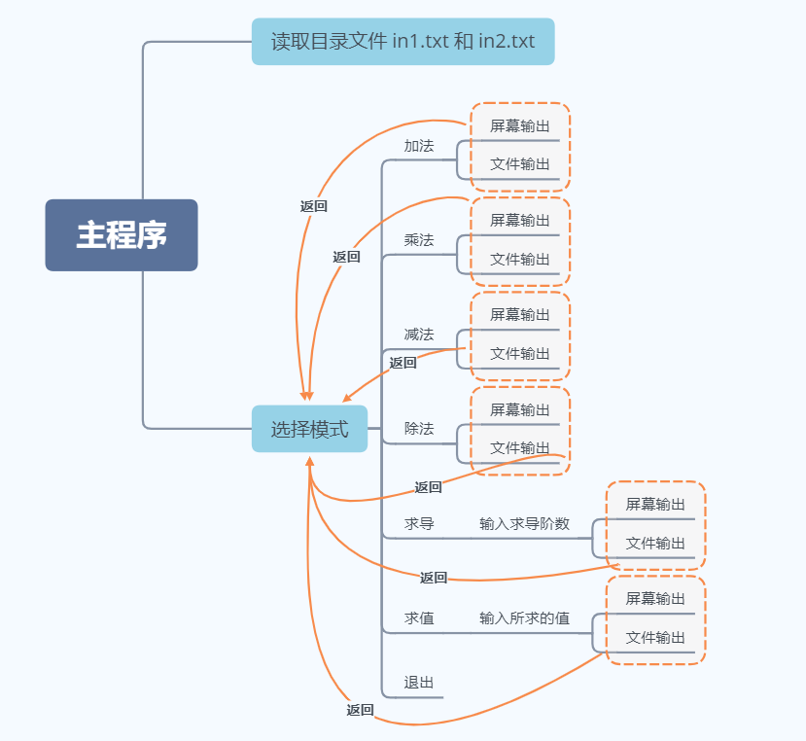
各程序模块之间的调用：
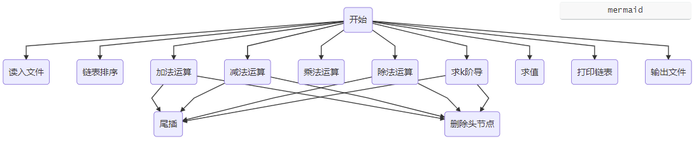
各算法主要步骤：
欧几里得算法步骤：
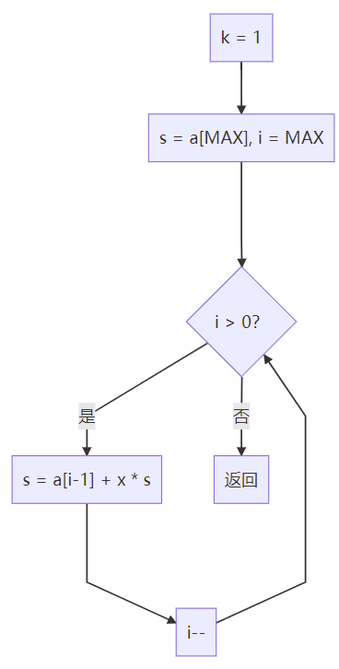
四、测试结果
通过文件输入的方式输入多项式：
in1：
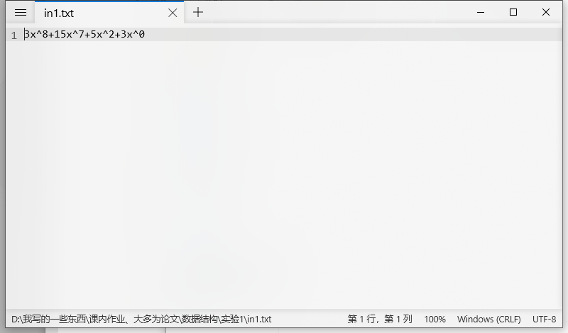

in2:
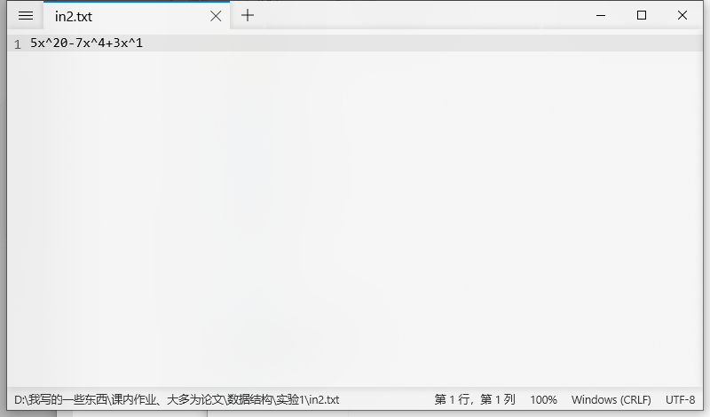

加法运算：
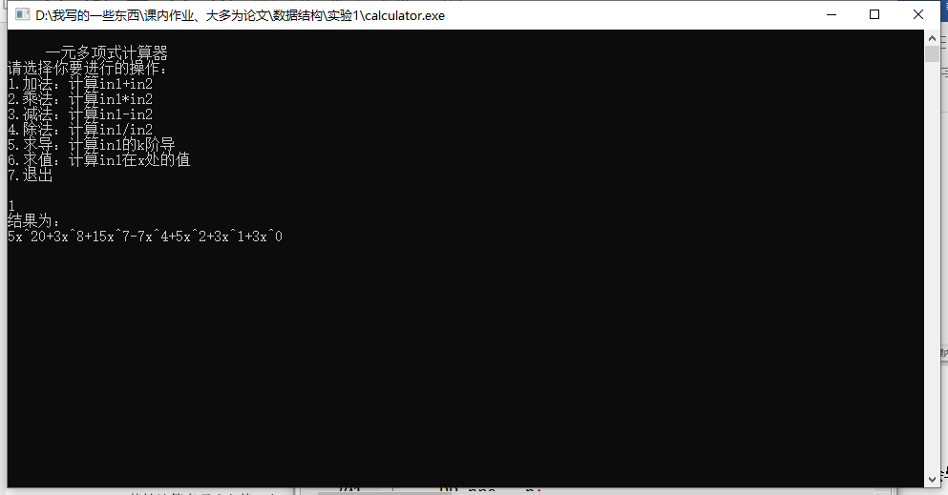

乘法运算：
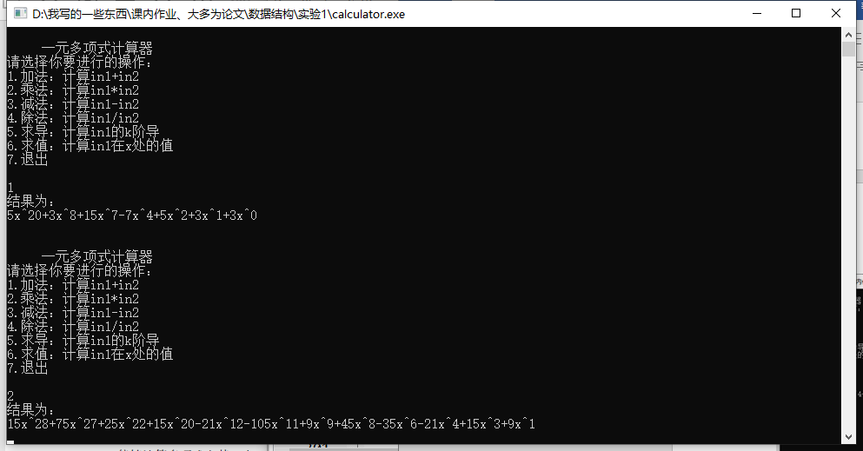

减法运算：
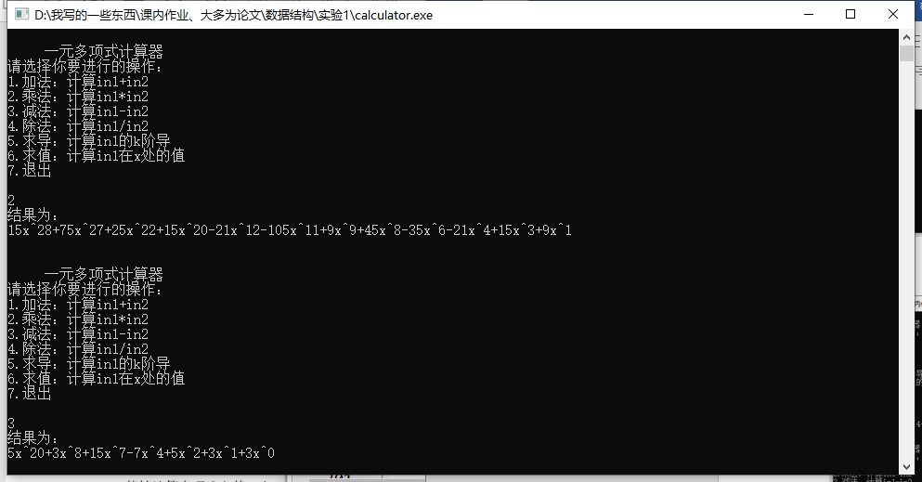

求导：
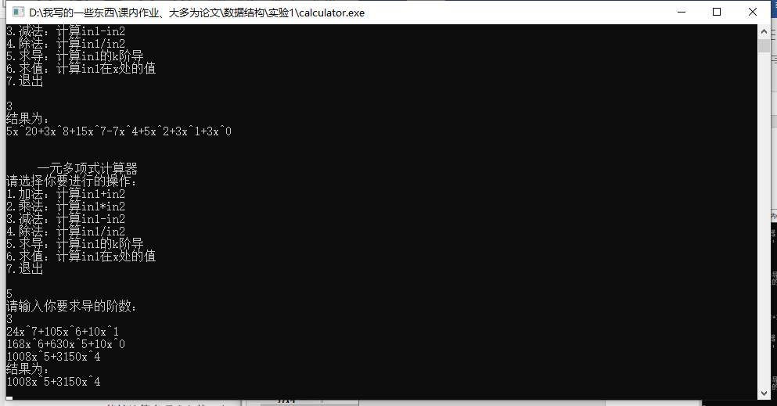

求值：
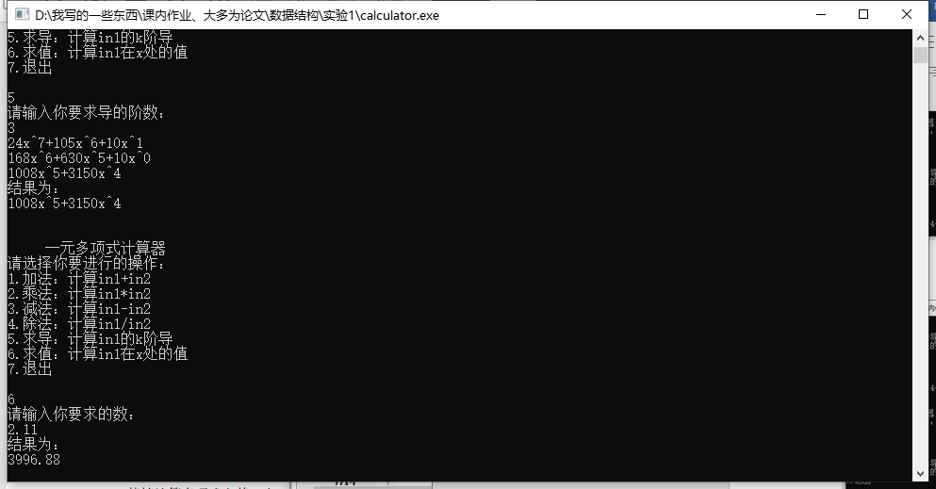

文件输出：
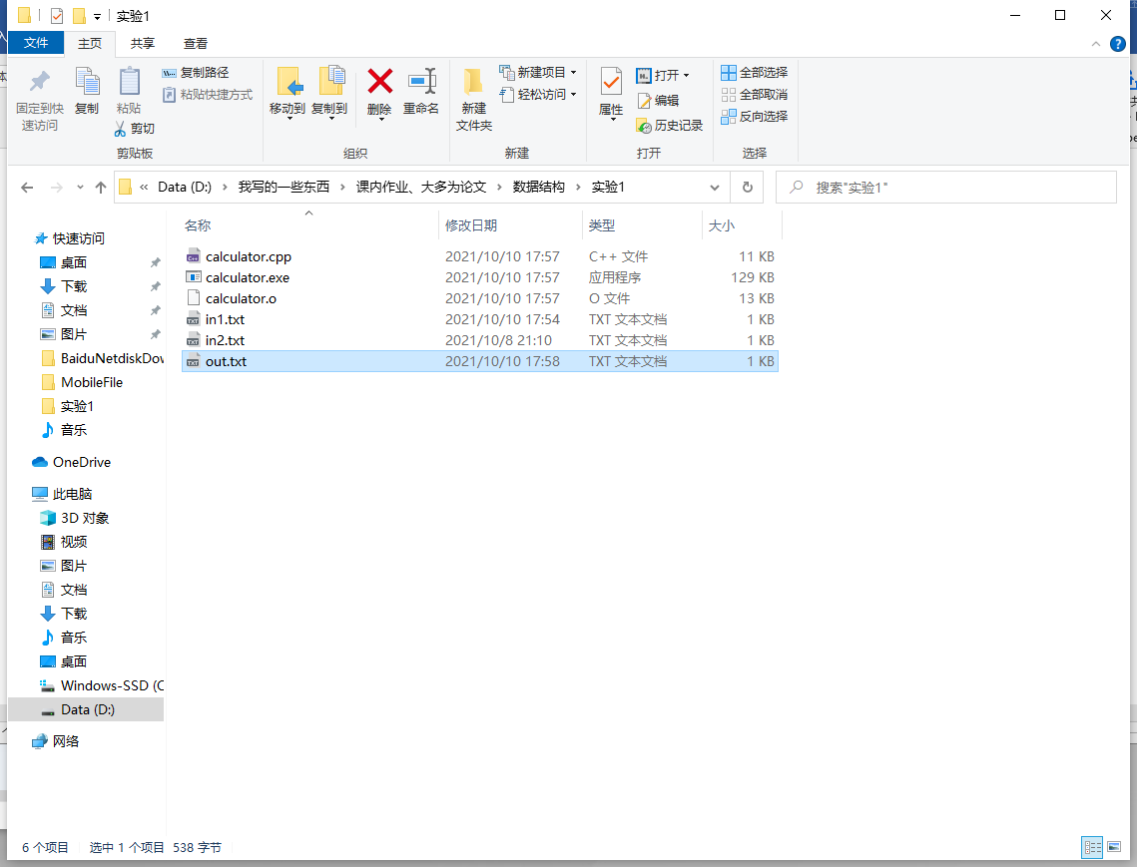
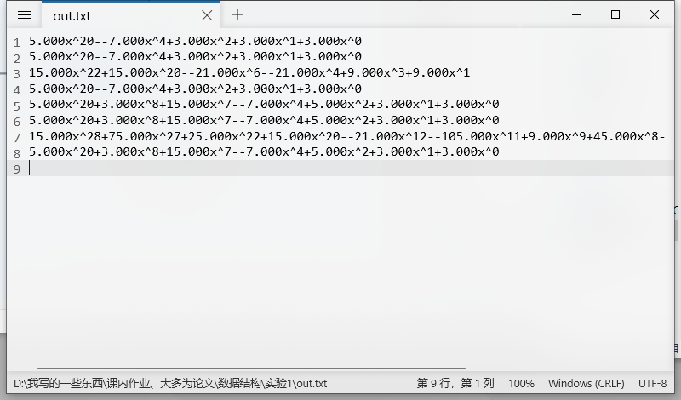
五、经验体会与不足
经验体会：提高了对链式存储结构的认识，对模块化编程有了更深的理解。
不足：程序的健壮性还是不够，加减乘除运算各函数之间的调用架构可以进一步优化。对文件操作掌握不够，否则可以进一步优化输出。
六、附录：源代码（带注释）
- #include <iostream>
- using namespace std;
- const int N = 6;
- typedef struct PolyNode *PP;
- struct PolyNode
- {
- float coef;
- int expon;
- PP next;
- };
- //删除头节点
- void deletehead(PP &p)
- {
- PP t = new struct PolyNode;
- t = p;
- p = p->next;
- delete t;
- }
- //尾插法，遍历指针后移
- void Attach(float c, int e, PP &Rear)
- {
- PP P= new struct PolyNode;
- P->coef = c;
- P->expon = e;
- P->next = NULL;
- Rear->next = P;//新的节点连上
- Rear = P;//尾节点更新
- }
- //归并排序，降幂
- PP Sort(PP &p)
- {
- if(p==NULL||p->next==NULL)
- return p;
- PP mid = p,right = p->next;
- while(right&&right->next)
- {
- right = right->next->next;
- mid = mid->next;
- }//mid在中间
- PP i = p,j = mid->next;
- mid->next = NULL;
- i = Sort(i);
- j = Sort(j);
- PP res = new PolyNode;
- PP Rear = res;
- while(i&&j)
- {
- if(i->expon>=j->expon)
- {
- Attach(i->coef,i->expon,Rear);
- i = i->next;
- }
- else
- {
- Attach(j->coef,j->expon,Rear);
- j = j->next;
- }
- }
- while(i)
- {
- Attach(i->coef,i->expon,Rear);
- i = i->next;
- }
- while(j)
- {
- Attach(j->coef,j->expon,Rear);
- j = j->next;
- }
- deletehead(res);
- return res;
- }
- //文件中读入多项式,不可重复指数
- PP ReadPoly(FILE *ff)
- {
- int e;
- float c;
- char ch;
- PP p = new struct PolyNode;
- p->next = NULL;
- PP Rear = p;
- ch = fgetc(ff);
- //第一项可能有符号也可能没有符号
- if (ch != '-')
- {
- rewind(ff);
- fscanf(ff,"%fx^%d",&c,&e);
- Attach(c,e,Rear);
- }
- else
- {
- fscanf(ff,"%fx^%d",&c,&e);
- Attach(c,e,Rear);
- }
- while (fscanf(ff,"%c%fx^%d",&ch,&c,&e) != EOF)
- {
- if (ch == '+')
- {
- Attach(c,e,Rear);
- }
- if (ch == '-')
- {
- Attach(-c,e,Rear);
- }
- }
- Rear->next = NULL;
- deletehead(p);
- return p;
- }
- //多项式加法
- PP Add(PP P1,PP P2)
- {
- if(!P1||!P2)
- cout<<"加法计算传入错误！"<<endl;
- PP t1 = P1;
- PP t2 = P2;
- PP P;
- PP Rear;
- P = new struct PolyNode;
- P->next = NULL;
- Rear = P;
- while(t1&&t2)
- {
- if(t1->expon==t2->expon)
- {
- if(t1->coef+t2->coef!=0)
- Attach(t1->coef+t2->coef,t1->expon,Rear);
- t1=t1->next;
- t2=t2->next;
- }
- else if(t1->expon>=t2->expon)
- {
- Attach(t1->coef,t1->expon,Rear);
- t1=t1->next;
- }
- else
- {
- Attach(t2->coef,t2->expon,Rear);
- t2=t2->next;
- }
- }
- while(t1)
- {
- Attach(t1->coef,t1->expon,Rear);
- t1 = t1->next;
- }
- while(t2)
- {
- Attach(t2->coef,t2->expon,Rear);
- t2 = t2->next;
- }
- Rear->next=NULL;
- deletehead(P);
- return P;
- }
- //多项式乘法
- PP Mult(PP P1,PP P2)
- {
- if(!P1||!P2)
- cout<<"乘法计算传入错误！"<<endl;
- PP P,Rear,t1,t2,t;
- float c;
- int e;
- t1=P1;
- t2=P2;
- P = new struct PolyNode;
- P->next = NULL;
- Rear=P;
- while(t2) //P1第1项乘以P2各项作为P
- {
- Attach(t1->coef*t2->coef,t1->expon+t2->expon,Rear);
- t2=t2->next;
- }
- t1=t1->next;
- while(t1)
- {
- t2=P2;
- Rear = P;
- while(t2)
- {
- e=t1->expon+t2->expon;
- c=t1->coef*t2->coef;
- while(Rear->next&&Rear->next->expon>e)
- Rear = Rear->next;//找到要插入的位置
- if(Rear->next&&Rear->next->expon==e)
- {
- if(Rear->next->coef+c)
- Rear->next->coef+=c;
- else
- {
- t=Rear->next;
- Rear->next = t->next;
- delete t;//清除之后系数为0的节点
- }
- }
- else //将新的插入后面
- {
- t=new struct PolyNode;
- t->coef = c;
- t->expon=e;
- t->next = Rear->next;
- Rear->next = t;
- Rear=Rear->next;
- }
- t2=t2->next;
- }
- t1=t1->next;
- }
- deletehead(P);
- return P;
- }
- //多项式减法(P1-P2)
- PP Subtract(PP P1,PP P2)
- {
- if(!P1||!P2)
- cout<<"减法运算传入错误！"<<endl;
- PP t1 = P1,t2 = P2,Rear;
- PP sub = new struct PolyNode;
- sub->next = NULL;
- Rear = sub;
- while(t1&&t2)
- {
- if(t1->expon==t2->expon)
- {
- if(t1->coef-t2->coef!=0)
- {
- Attach(t1->coef-t2->coef,t1->expon,Rear);
- }
- t1=t1->next;
- t2=t2->next;
- }
- else if(t1->expon>=t2->expon)
- {
- Attach(t1->coef,t1->expon,Rear);
- t1=t1->next;
- }
- else
- {
- Attach(t2->coef,t2->expon,Rear);
- t2=t2->next;
- }
- }
- while(t1)
- {
- Attach(t1->coef,t1->expon,Rear);
- t1 = t1->next;
- }
- while(t2)
- {
- Attach(-t2->coef,-t2->expon,Rear);
- t2 = t2->next;
- }
- Rear->next=NULL;
- deletehead(sub);
- return sub;
- }
- //除法
- //p1 = p2*ress+resy
- //ress为商多项式，resy为余数多项式
- void Division(PP p1,PP p2,PP ress,PP resy)
- {
- if(!p1||!p2)
- cout<<"除法运算传入错误！"<<endl;
- ress->next = NULL;
- resy->next = NULL;
- PP Rears = ress;
- PP Reary = resy;
- PP t = p2;
- for(int i =p1->expon; i>=p2->expon; i--)
- {
- int e = i-p2->expon;
- int c = p1->coef/p2->coef;
- Attach(c,e,Rears);
- while(t)
- {
- p1->coef -= t->coef*c;
- t = t->next;
- }
- }
- t = p2;
- while(t)
- {
- Attach(t->coef,t->expon,Reary);
- }
- Rears->next = NULL;
- Reary->next = NULL;
- deletehead(ress);
- deletehead(resy);
- }

- //求导
- void Deri(PP p)
- {
- if(!p)
- return;
- PP t = p;
- while(t){
- t->coef = t->coef*t->expon;
- t->expon--;
- t = t->next;
- }
- PP pre = p;
- t = p->next;
- while(t){
- if(t->coef==0){
- pre->next = t->next;
- delete t;
- t = pre->next;
- }
- else{
- t = t->next;
- pre = pre->next;
- }

- }
- }
- //秦九韶算法求值
- float cal(PP p,float x){
- int Max = p->expon;
- float a[Max+1]={0};
- while(p){
- a[p->expon] = p->coef;
- p = p->next;
- }
- int k = 1;
- float s = a[Max];
- for(int i = Max; i > 0; i--){
- s = a[i-1] + x * s;
- }
- return s;
- }
- //输出多项式
- void PrintPoly(PP P)
- {
- if(!P)
- {
- cout<<"0"<<endl;
- return;
- }
- cout<<P->coef<<"x^"<<P->expon;
- P = P->next;
- while(P)
- {
- if(P->coef>0)
- cout<<"+";
- cout<<P->coef<<"x^"<<P->expon;
- P=P->next;
- }
- cout<<"\n";
- }
- //输出文件
- void OutFile(PP p){
- if (!p){
- cout<<"输入异常！"<<endl;
- return;
- }
- FILE *fp = NULL;
- fp = fopen("out.txt","a");
- char ch;
- ch = getc(fp);
- if (ch != '-'){
- rewind(fp);
- fprintf(fp,"%.3fx^%d",p->coef,p->expon);
- }
- else{
- rewind(fp);
- fprintf(fp,"-%.3fx^%d",p->coef,p->expon);
- }
- p = p->next;
- while (p){
- if (p->coef>0){
- fprintf(fp,"+%.3fx^%d",p->coef,p->expon);
- }
- else{
- fprintf(fp,"-%.3fx^%d",p->coef,p->expon);
- }
- p = p->next;
- }
- fprintf(fp,"\n");
- fclose(fp);
- }
- int main(void)
- {
- while(1)
- {
- //导入两个输入多项式
- PP P1,P2;
- FILE *fp1 = fopen("in1.txt","r");
- FILE *fp2 = fopen("in2.txt","r");
- if(fp1==NULL)
- {
- cout<<"打开文件in1.txt失败！"<<endl;
- exit(1);
- }
- else
- P1 = ReadPoly(fp1);
- if(fp1==NULL)
- {
- cout<<"打开文件in2.txt失败！"<<endl;
- exit(1);
- }
- else
- P2 = ReadPoly(fp2);
- fclose(fp1);
- fclose(fp2);

- P1 = Sort(P1);
- P2 = Sort(P2);
- //存储结果
- PP ans[N] = {NULL};
- int mode;//模式选择
- float x;//计算x的多项式值
- float anss;
- int k;//计算k阶导
- PP ress = new struct PolyNode;
- PP resy = new struct PolyNode;
- cout<<endl;
- cout<<" 一元多项式计算器 "<<endl;
- cout<<"请选择你要进行的操作："<<endl;
- cout<<"1.加法：计算in1+in2"<<endl;
- cout<<"2.乘法：计算in1*in2"<<endl;
- cout<<"3.减法：计算in1-in2"<<endl;
- cout<<"4.除法：计算in1/in2"<<endl;
- cout<<"5.求导：计算in1的k阶导"<<endl;
- cout<<"6.求值：计算in1在x处的值"<<endl;
- cout<<"7.退出"<<endl;
- cout<<endl;
- cin>>mode;
- switch(mode)
- {
- case 1:
- ans[1] = Add(P1,P2);
- cout<<"结果为："<<endl;
- PrintPoly(ans[1]);
- OutFile(ans[1]);
- break;
- case 2:
- ans[2] = Mult(P1,P2);
- cout<<"结果为："<<endl;
- PrintPoly(ans[2]);
- OutFile(ans[2]);
- break;
- case 3:
- ans[3] = Subtract(P1,P2);
- cout<<"结果为："<<endl;
- PrintPoly(ans[3]);
- OutFile(ans[3]);
- break;
- case 4:
- Division(P1,P2,ress,resy);
- cout<<"结果为："<<endl;
- cout<<"商多项式："<<endl;
- PrintPoly(ress);
- OutFile(ress);
- cout<<"余数多项式："<<endl;
- PrintPoly(resy);
- OutFile(resy);
- break;
- case 5:
- cout<<"请输入你要求导的阶数："<<endl;
- cin>>k;
- if(k>P1->expon)
- cout<<"0"<<endl;
- else{
- ans[5] = P1;
- while(k--)
- {
- Deri(ans[5]);
- PrintPoly(ans[5]);
- }
- cout<<"结果为："<<endl;
- PrintPoly(ans[5]);
- }
- break;
- case 6:
- cout<<"请输入你要求的数："<<endl;
- cin>>x;
- anss = cal(P1,x);
- cout<<"结果为："<<endl;
- cout<<anss<<endl;
- break;
- case 7:
- return 0;
- }
- getchar();
- getchar();
- }
- return 0;
- }

